
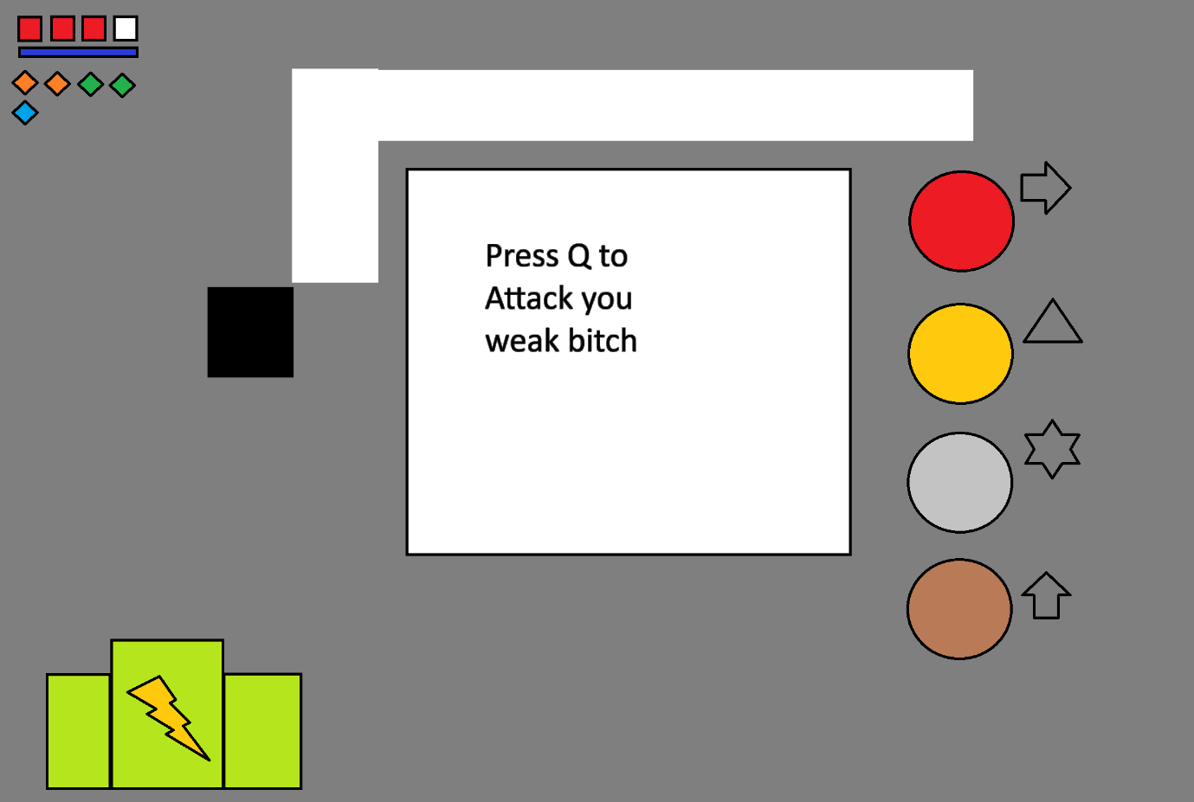
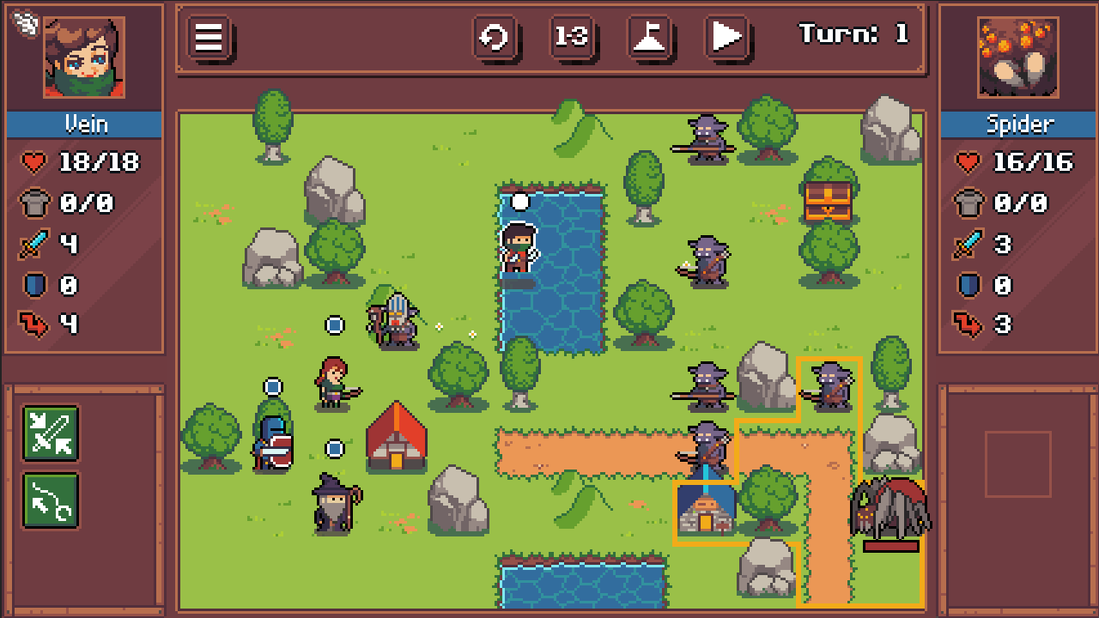
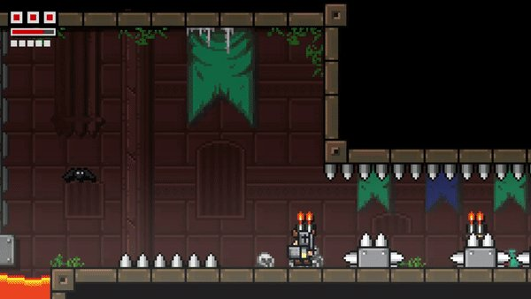
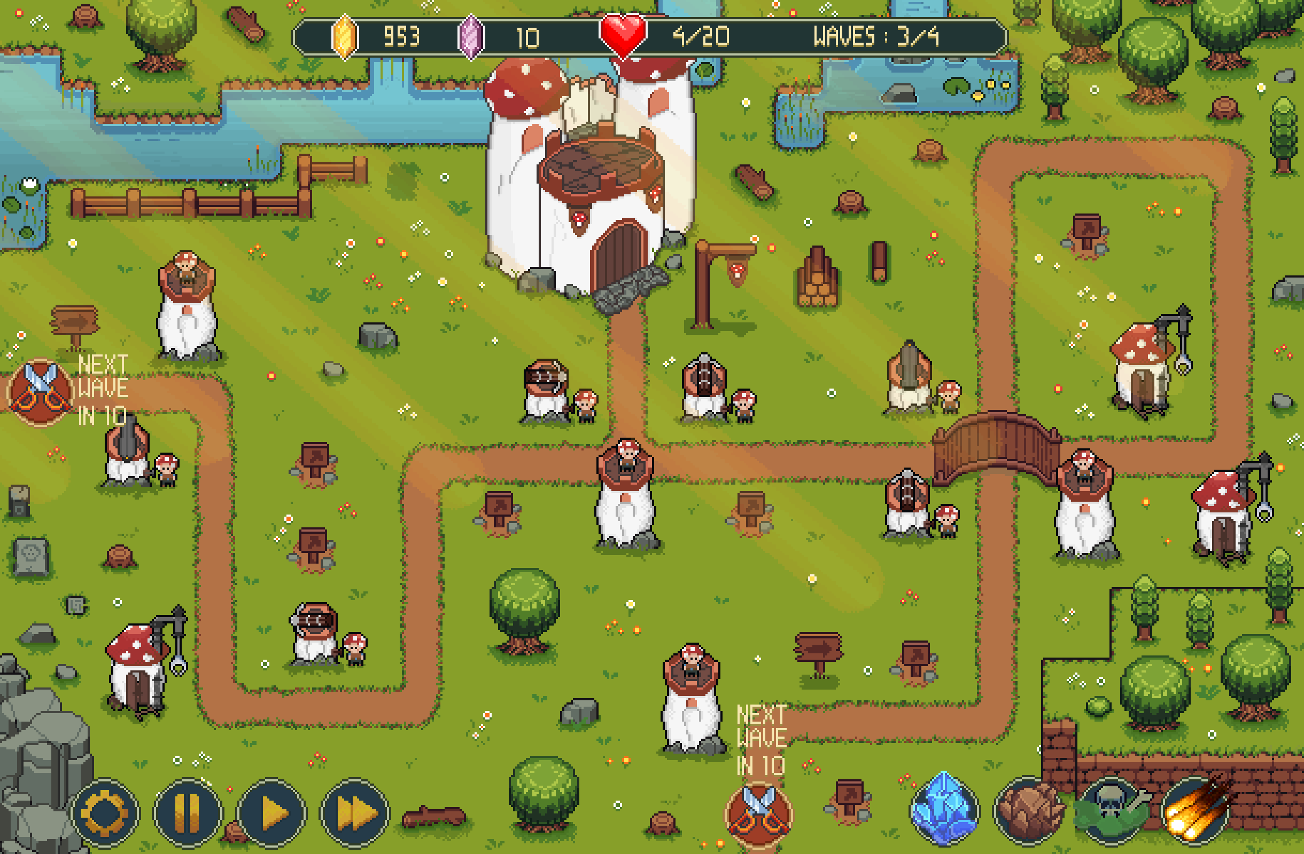

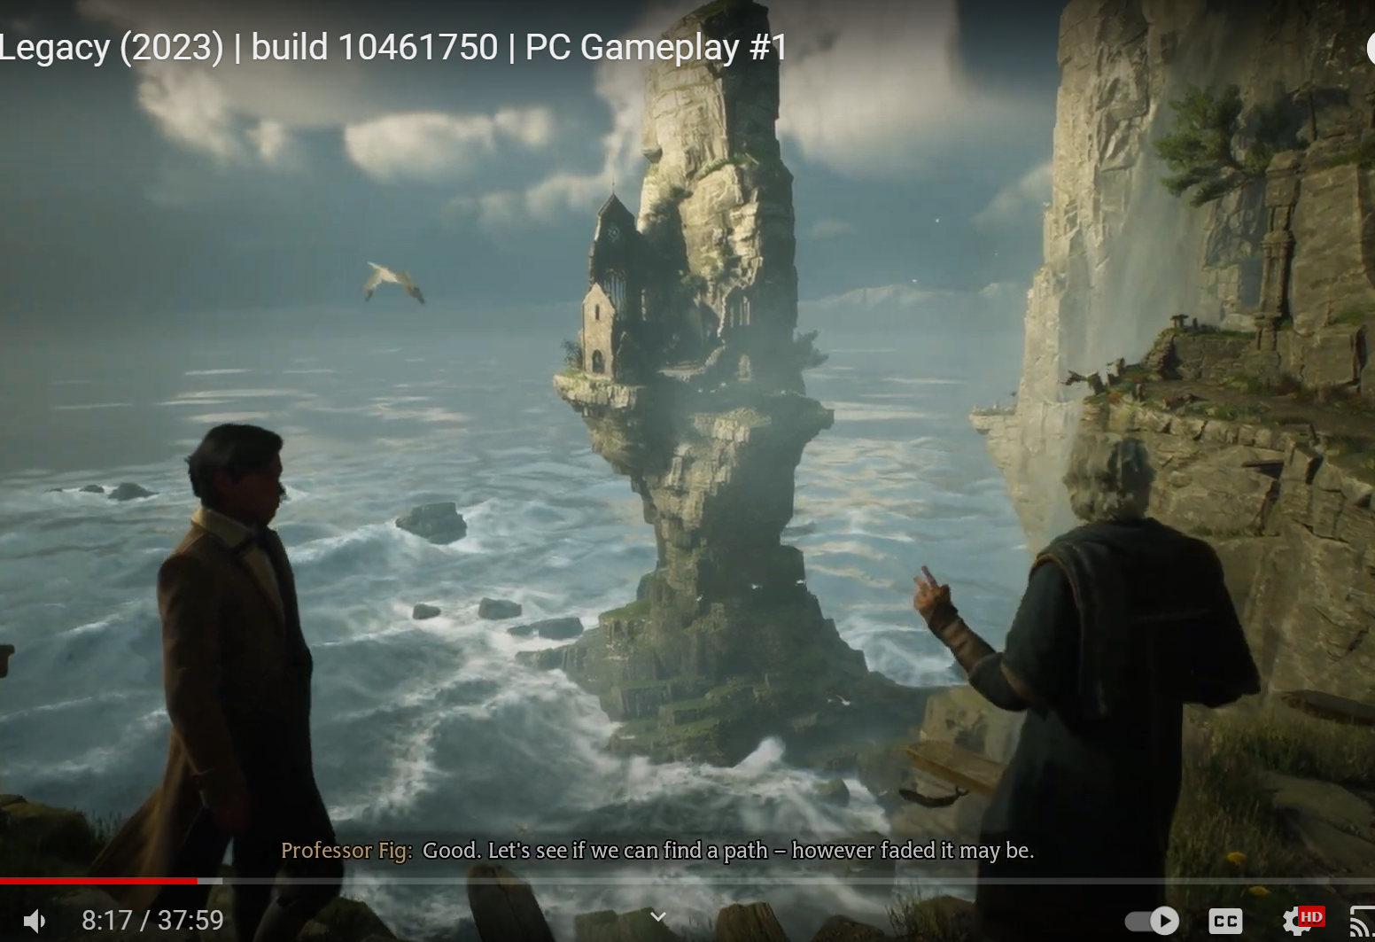
ok I am thinking this powerful mage dies (lets say he had to use a very powerful spell that desintegrated his body to save the world) fighting this evil (idk for now) and his magic is spread all over the dimensions (books/pages idk) the evil slowly starts coming back over centuries of gathering pieces of remaining of his magic and now each dimension has an (element) with every boss and somehow (lets say traces of evil make him come back to life as a skelleton {give me more ideas}) and he is reserected in his old solitary lighthouse (now this lighouse seems like it but its really a secret magic tower that gives access to this portal in the middle of the room which he has access to various words depending on his lvl lets say for game balance, it also has a magic craft to make the new books/spells using the scattered pieces of his old magic dropped by the bosses, bed to save the game, maybe a market idk give me more ideas also this progression tree which shows all his stats and damage, perhaps a training room too yes it can fit lots of stuff after all its a magic tower)

Resurrection and Initial Setup
The Mage's Sacrifice
- The Final Spell: Centuries ago, the powerful mage performed a spell of unimaginable power to seal away a great evil that threatened to consume all dimensions. This spell disintegrated his body, scattering his magic across the dimensions in the form of magical books or pages, each containing a fragment of his essence.
- The Evil's Return: Over time, the remnants of the evil force slowly began to reconstitute itself by gathering the scattered fragments of the mage’s magic. The evil's influence spread across the dimensions, corrupting them and imbuing each with a specific elemental force. As this evil grew stronger, it unwittingly triggered the mage's resurrection, albeit in a weakened, skeletal form.
Resurrection in the Lighthouse
- The Solitary Lighthouse: The mage's soul is drawn back to the physical world by traces of the evil force that reanimated him. He awakens in his old lighthouse, a solitary structure on the edge of a desolate shore. Unbeknownst to the outside world, this lighthouse is actually a powerful magical tower that served as the mage’s secret sanctum.
- Mystical Awakening: The mage’s reanimation is accompanied by a faint pulse of magical energy that briefly illuminates the lighthouse. The tower's dormant enchantments begin to awaken, revealing its true nature as the mage regains his consciousness.
The Magic Tower: A Hub for Progression
Central Chamber: The Nexus Room
- Portal of Dimensions: At the heart of the tower is a grand circular room with a portal in the center. This portal is the mage’s gateway to different dimensions, each one influenced by the elemental forces that the evil has corrupted. Initially, only the weakest dimensions are accessible, but as the mage regains power, more challenging dimensions unlock.
- Dimensional Gateways: The portal is surrounded by pedestals or obelisks, each linked to a specific element or dimension. As the mage defeats bosses and collects fragments of his lost magic, these obelisks light up, indicating that the corresponding dimension can be accessed or has been conquered.
The Arcane Workshop
- Book Crafting: Adjacent to the Nexus Room is the Arcane Workshop, where the mage can use fragments of his old magic (dropped by bosses or found in levels) to craft new spellbooks. Each book represents a spell or a set of spells tied to an element, and combining different fragments can create hybrid or more powerful spells.
- Spell Customization: The workshop also features a spell customization table, where the mage can modify and upgrade his spells. For example, a basic fireball spell can be enhanced to split into multiple projectiles or leave a lingering flame on the ground.
The Memory Archive
- Progression Tree: This room houses the mage’s progression tree, which is a vast, glowing tapestry or a mystical tome that records the mage’s regained powers and stats. As the mage levels up and defeats bosses, he can unlock new abilities, improve his stats, and enhance his elemental affinities.
- Training Room: Connected to the Archive is a training room, where the mage can test out new spells and abilities in a safe environment. This room could feature magical constructs or dummies that simulate different elemental resistances and combat scenarios.
The Sanctum of Rest
- Bed and Save Point: The mage’s resting quarters, where he can save his progress by resting. The bed could also serve as a checkpoint system, where resting restores health and magic but also progresses time, possibly affecting the world outside.
- Vision Dreams: Occasionally, when the mage sleeps, he experiences visions or flashbacks that provide more context about his past, the kingdom's downfall, and the nature of the evil he once fought. These dreams can also hint at the locations of powerful relics or secrets hidden in the dimensions.
The Enchanted Market
- Resource Trading: A hidden door in the tower leads to a mystical market that is accessible only to those who possess magical knowledge. Here, the mage can trade the souls or remnants collected from defeated enemies for rare items, powerful spells, or upgrades to his equipment.
- Mysterious Merchants: The market is populated by enigmatic merchants—each one representing different magical schools or elements. They offer unique goods and services, such as rare spell components, enchantments for existing spells, or scrolls that reveal hidden paths in the dimensions.
The Observatory
- Dimensional Surveillance: At the top of the tower is the observatory, a chamber with a panoramic view of the surrounding dimensions. The mage can use this room to scout the elemental realms, seeing glimpses of the challenges ahead or identifying the locations of hidden secrets.
- Astrological Enhancements: The observatory also houses ancient star charts and magical instruments. By aligning certain constellations or harnessing celestial events, the mage can temporarily boost his abilities or weaken the elemental forces in a particular dimension.
Gameplay Loop and Progression
Exploration and Combat
- Dimensional Exploration: The mage travels through the portal to explore various dimensions, each themed around a different element. Each dimension is a self-contained level with unique environmental hazards, enemies, and a boss that holds a fragment of the mage’s magic.
- Elemental Puzzles: Dimensions are filled with puzzles that require the mage to use different spells or elements. For instance, freezing water to create a path, or using wind to clear toxic gas. These puzzles not only provide progression but also tie into the elemental theme of each dimension.
Boss Battles
- Elemental Guardians: Each dimension is guarded by a powerful elemental boss that has been corrupted by the evil force. These bosses drop pages or fragments of the mage’s old spellbook, which can be collected and reassembled to unlock new powers.
- Tactical Combat: Bosses have unique patterns and elemental strengths and weaknesses, encouraging players to use specific spells or strategies to exploit their vulnerabilities.
Crafting and Customization
- Spell Evolution: As the mage collects fragments of his old magic, he can craft new spellbooks or enhance existing ones. The more fragments he gathers, the more powerful and versatile his magic becomes.
- Bookbinding System: In the workshop, the mage can combine different elements to create unique spells. For example, combining fire and air might create a spell that summons a firestorm, while combining earth and water could produce a spell that creates protective mud barriers.
Narrative Integration
- Unraveling the Past: As the mage progresses, he uncovers more about his past and the events that led to the cataclysm. This could be done through interactions with NPCs in the market, discovering ancient texts, or experiencing visions during sleep.
- Moral Dilemma: Toward the end of the game, the mage might face a moral choice that affects the ending. Does he reclaim all his lost power, risking the return of the very evil he once fought, or does he sacrifice his power once again to ensure the safety of the world?
Visual and Audio Themes
- Visual Design: The lighthouse/tower should feel both ancient and mystical, with a blend of rustic and arcane elements. Animated details, like floating books, flickering candles, and shifting magical runes, would enhance the atmosphere.
- Sound Design: Each room in the tower could have its own ambient sound, from the hum of magical energy in the workshop to the crackling fire in the bedchamber. The observatory could have soft, celestial music, adding to the mystique.
This structure gives you a detailed and cohesive world where gameplay, story, and setting are tightly intertwined. The tower acts as both a physical and narrative hub, with each feature serving a purpose in the mage’s journey to reclaim his lost power and confront the resurgent evil.

This is an intriguing concept for a game! I'll break down your ideas and offer some suggestions to expand on them:
- Main Premise:
  - A powerful mage sacrifices himself to save the world
  - His magic scatters across dimensions
  - An evil force slowly regathers the magic over centuries
  - The mage is resurrected as a skeleton to fight the evil again
- The Mage's Resurrection:
  - Skeleton form: This is a great start
  - Additional ideas:
    - Ethereal form: Part corporeal, part ghostly
    - Elemental body: Changes based on the magic he regains
    - Golem-like construct: Made from materials in his lighthouse
    - Spectral projection: Can possess objects or creatures temporarily
- The Lighthouse/Magic Tower:
  - Secret magic tower disguised as a lighthouse
  - Central portal to access various worlds
  - Features:
    - Crafting area for new spells/books
    - Bed to save the game
    - Progression tree for stats and damage
    - Training room
  - Additional ideas:
    - Library: To store collected spell books and lore
    - Observatory: To track magical disturbances across dimensions
    - Alchemy lab: For creating potions and magical items
    - Meditation chamber: To regain energy and unlock memories
    - Artifact display: To showcase powerful items collected on journeys
    - Dimensional map room: To plan strategies and track progress
    - Familiar nursery: To raise magical companions
- Gameplay Elements:
  - Defeat bosses in different dimensions to regain magic
  - Collect scattered pieces of old magic to craft new spells
  - Unlock access to new dimensions as you level up
  - Progression tree for stats and abilities
- Additional Ideas:
  - Elemental affinity system: Each dimension has a dominant element
  - Time manipulation: The lighthouse exists outside normal time flow
  - Memory fragments: Collect pieces of the mage's past to unlock powerful abilities
  - Dimensional rifts: Mini-dungeons that appear randomly for bonus challenges
  - Magical ecosystems: Each dimension has unique flora and fauna affected by magic
  - Allies from the past: Summon or encounter old friends/apprentices of the mage
  - Alternate timeline versions of the mage: Encounter "what if" scenarios
This concept offers a rich foundation for an engaging game with plenty of room for exploration, character development, and creative gameplay mechanics. The central hub (lighthouse) provides a great focal point for the player to return to between adventures, upgrade abilities, and progress the story.

bare in mind this is a top down pixel art game
Edit
Understood. A top-down pixel art game offers a unique set of opportunities and constraints. Let's refine the concept to fit this style:
- Visual Style:
  - Retro-inspired pixel art with a limited color palette
  - Top-down perspective for exploration and combat
  - Simple but expressive character animations
- Lighthouse/Magic Tower:
  - Multi-room structure viewed from above
  - Each room has a distinct purpose and visual theme
  - Rooms to include:
    - Portal room (center)
    - Spell crafting area (workbench with bubbling potions)
    - Bedroom (save point)
    - Library (scrolling bookshelves)
    - Training dummy area
  - Transition between rooms by walking through doorways
- Mage Character:
  - Skeletal form with a billowing robe
  - Magic staff or wand as primary weapon
  - Visual changes as you gain elemental powers (e.g., flaming skull, icy bones)
- Gameplay Mechanics:
  - Move with directional keys/stick
  - Use simple button combinations for spells
  - Interact with objects by approaching and pressing a button
  - Menu-based inventory and spell management
- World Design:
  - Each dimension is a distinct map with its own tile set
  - Unique enemies and obstacles themed to each dimension
  - Boss arenas at the end of each dimension
- UI Elements:
  - Minimalist HUD showing health, mana, and current spell
  - Pause menu for more detailed character info and settings
  - Progression tree could be a constellation-like map of stars
- Additional Features:
  - Collectable spell pages appear as glowing scrolls
  - Bosses drop larger, pulsating orbs of magic
  - Dimensional portals are swirling vortexes of pixel particles
  - Simple weather effects (rain, snow) to differentiate dimensions
  - Day/night cycle in the lighthouse to mark progress
- Sound Design:
  - Chiptune-style music to match the retro aesthetic
  - Simple sound effects for spells, interactions, and enemy noises
- Progression:
  - Visible changes to the mage as they gain power (more complex robes, glowing effects)
  - Lighthouse slowly repairs and expands as you progress
- Mini-games or Puzzles:
  - Simple puzzle elements like pushing blocks or activating switches
  - Pattern-matching minigame for spell crafting
  - Memory-style game for unlocking the mage's past
Remember, in a top-down pixel art game, it's important to convey information clearly through simple visuals. Use color, animation, and particle effects to distinguish between different spells, enemies, and interactive elements. The charm of this style often comes from creative use of limited resources, so focus on making each element distinct and memorable within the constraints of pixel art.

